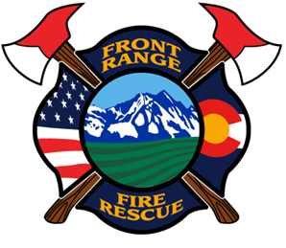
FRONT RANGE FIRE RESCUE

MEETING NOTICE

FRONT RANGE FIRE RESCUE FIRE PROTECTION DISTRICT
Board Meetings 2018

All meetings will begin at 6:00pm, at St. 2, 101 S. Irene Ave., Milliken, CO 80543. In the months, the Pension board meets, the District meeting will begin immediately after the Pension board meets.

January 10, 2018
February 14, 2018*
March 14, 2018
April 11, 2018
May 9, 2018*
June 13, 2018
July 13, 2018
August 8, 2018*
September 12, 2018
October 10, 2018
November 14, 2018*
December 12, 2018

*Pension Board Meetings

February 14, 2018, 6:00 pm
May 9, 2018, 6:00 pm
August 8, 2018, 6:00 pm
November 14, 2018, 6:00 pm

Ambulance Oversight Committee Meeting

April 19, 2018 at 1700 hours at Front Range Fire Rescue, Station 2, 101 S. Irene, Milliken
September 13, 2018 at 1700 hours at Windsor Severance Fire Station, 100 7th Street, Windsor

All meetings are open to the public. Agendas are posted 24 hours prior to meetings.
For more information email info@frfr.co or go to www.frfr.co

